2. Write a C program to find Odd or Even number from a given set of numbers

**Aim:**To write a C program to read a set of numbers and determine whether each number is odd or even.

**Algorithm**

1. Start the program.
2. Declare an array to store the numbers.
3. Input how many numbers (n) the user wants to check.
4. Loop through n times and read the numbers into the array.
5. For each number in the array:
   * If the number is divisible by 2 (num % 2 == 0), it is **Even**.
   * Otherwise, it is **Odd**.
6. Display the result for each number.
7. Stop the program.

**Program:**

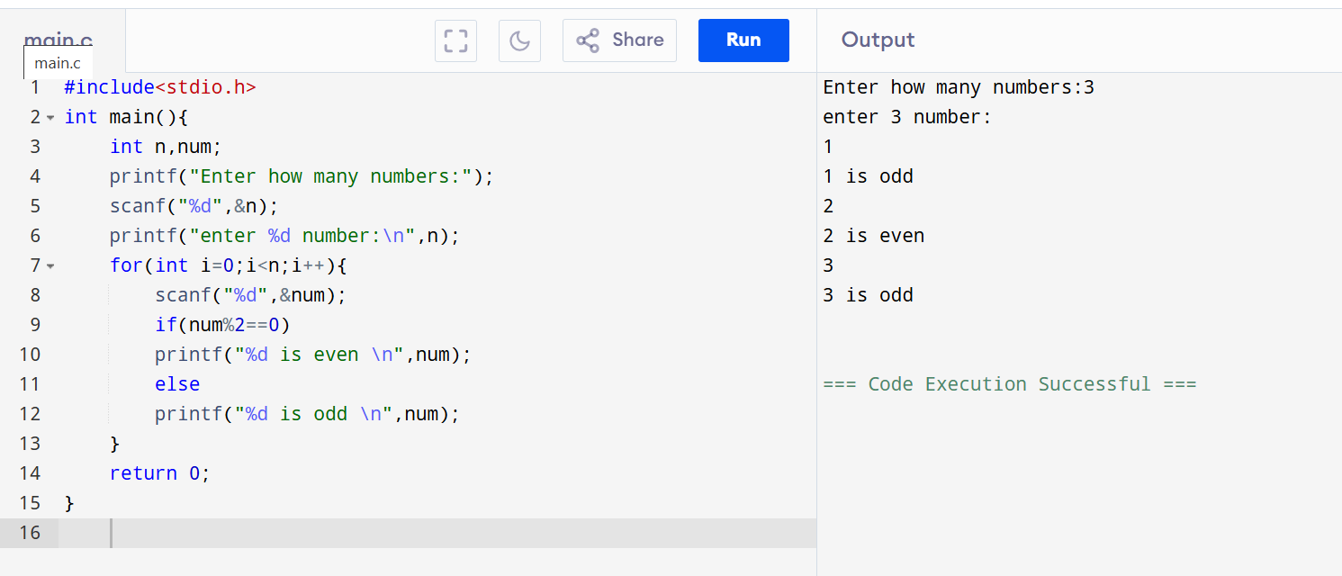

**Result:** Thus, the C program was successfully executed to determine whether the given set of numbers are Odd or Even.